**PROPOSAL**

**INDOOR POSITIONING SYSTEM USING REGRESSION-BASED FINGERPRINT METHOD**



**RESEARCH**

*REGINALD PUTRA GHOZALI*

*1901788846*

**Graduate Program in Computer Studies**

**STUDY PROGRAM MASTER OF INFORMATION TECHNOLOGY**

**UNIVERSITAS BINA NUSANTARA**

**JAKARTA**

**2018**

**PROPOSAL**

**INDOOR POSITIONING SYSTEM USING REGRESSION-BASED FINGERPRINT METHOD**



**RESEARCH**

*REGINALD PUTRA GHOZALI*

*1901788846*

**Supervisor:**

**I Gede Putra Kusuma Negara, B.Eng., PhD  
Date: 1 November 2018**

**TABLE OF CONTENTS**

**TABLE OF CONTENTS …………………………………………………………... i**

**LIST OF TABLES …………………………………………………………………. ii**

**LIST OF FIGURES ……………………………………………………………….. iii**

**CHAPTER 1 INTRODUCTION ..………………………………………………… 1**

* 1. Background ……………………………………………………………………... 1
  2. Problem Formulation ………………………………………………………….… 4
  3. Goals And Benefits …………………………………….…………………….….. 4
  4. Scope of Work ....................................................................................................... 5

**CHAPTER 2 THEORETICAL BASIS …………………………………………… 6**

* 1. Related Works …………………………………………………………………... 6
  2. Bluetooth Low Energy ………………………………………………………….13
  3. Indoor Positioning System Using Fingerprinting ……………………………….14
  4. Deep Learning …………………………………………………………………..16
  5. Convolutional Neural Networks ………………………………………………...17

**CHAPTER 3 METHODOLOGY ………………………………………………… 21**

* 1. Framework of Thought ………………………………………………………… 21
  2. Research Process ………………………………………………………………. 22
  3. Proposed Design ……………………………………………………………….. 24
  4. Evaluation ……………………………………………………………………... 26
     1. Evaluation Method …………………………………………………………. 26
     2. Data Collection ……………………………………………………………... 26
     3. Experimental Design ……………………………………………………….. 27
     4. Performance Metric ………………………………………………………… 30

**BIBLIOGRAPHY ………………………………………………………………… 31**

**LIST OF TABLES**

Table 3.1 Radio Map Database for 6 Beacons Example …………………………… 28

**LIST OF FIGURES**

Figure 2.1 nRF51822 Bluetooth Smart Beacon Kit ….…………………………….. 13

Figure 2.2 GoogLeNet Inception Layer …………..………………………………... 20

Figure 2.3 Convolutional Neural Networks Architectures .………………………… 20

Figure 3.1 Framework of Thought ………………………………………………….. 21

Figure 3.2 Research Process ………………………………………………………... 22

Figure 3.3 Coordinate Map ………………………………………………………… 23

Figure 3.4 Proposed Method’s Illustration ...……………………………………….. 25

Figure 3.5 Map with 15 Beacons ……………….………………………………….. 27

Figure 3.6 8-Fold Cross Validation …………………………………………………. 29

**CHAPTER I**

**INTRODUCTION**

* 1. **Background**

Indoor positioning has become popular research topic in current days as this system can be used for diverse purposes. Compared with outdoor positioning like Global Positioning System (GPS), that did not work in indoor environment, indoor positioning using Radio Frequency (RF) gives possibilities in indoor environment with limitation of bandwidth needed depending how large the indoor environment (Terán, Aranda, Carrillo, Mendez, & Parra, 2017). Current challenge when using Radio Frequency is estimating position using signal strength received, because radio frequency has weakness like disturbances from human body that affect radio signals (Topak, Pekeriçli, & Tanyer, 2018). Others are uncertainty of signal strength due to fast frequency received that needs waiting time to show different position of moving person (Contreras, Castro, & de la Torre, 2017) and random behavior of received signal strength (Terán, Aranda, Carrillo, Mendez, & Parra, 2017).

Many technologies have been used. Starting with optical type (infrared (Santo, Maekawa, & Matsushita, 2017) and visible light communication (Zhang, Chowdhury, & Kavehrad, 2014)), sounds (Moutinho, Araújo, & Freitas, 2016) (Yayan & Yucel, 2015), and radio-frequency (Wi-Fi (Thuong, Phong, Do, Van Hieu, & Loc, 2016) and Bluetooth (Faragher & Harle, 2015) (Faragher & Harle, 2014). Among them, Bluetooth low energy (BLE) has been used frequently by reasons of low cost, very low battery consumption, and high availability as supported by most modern smartphones.

BLE used 2.4 GHz unlicensed frequency (2402 to 2480 MHz) with total of 40 channels (2 MHz for each channel width). And using 3 channels for discovery services (channel 37, 38, 39) (Faragher & Harle, 2015) (Faragher & Harle, 2014). Many algorithms have been used for optimizing accuracy of the system. Such as multilateration and fingerprinting. Even so, there is not yet optimized solutions for high accuracy using BLE technology (Brena, et al., 2017).

There are many factor that affect the BLE radio propagation of the signals in indoor environments as BLE using radio signals, e.g., multipath effect, causing a random behavior in the Received Signal Strength (RSS) measurements caused by reflection (Terán, Aranda, Carrillo, Mendez, & Parra, 2017), movement rate of user (Topak, Pekeriçli, & Tanyer, 2018), and fast fading when measuring within a little time (Contreras, Castro, & de la Torre, 2017). To solve these problems, fingerprinting method is needed to estimate indoor position that needs estimation algorithm to ensure accuracy of position.

To get object’s location based on received signal strength from BLE, certain measurement method is needed. Current popular method is fingerprinting. Where localization algorithms used for measure or estimate location. It consists at least 2 steps: training step and determine position. Training step used to create a radio mapping of possible location from given signal strength received. While determine position step (Brena, et al., 2017) will match the received signals during online moments with radio mapping from previous step to determine object’s location. Older method to get object’s location using geometrical methods like trilateration (Rida, Liu, Jadi, Algawhari, & Askourih, 2015) to measure distance and position of person.

Many researchers tried to find optimized algorithm for indoor positioning. Some used k-nearest neighbor (Yu, et al., 2014) to estimate nearest points that can represent person’s position using classification, while certain researchers A few other tried regressions to estimate position like polynomial regression (Zhuang, Yang, Li, Qi, & El-Sheimy, 2016), where cumulative distribution function is related with error rate of average distance estimation. From these algorithms, regression model gives higher accuracy if compared with others. Given Polynomial Regression Model can solve multipath problems that gives random behavior of received signal strength (Zhuang, Yang, Li, Qi, & El-Sheimy, 2016).

Current state-of-the-art (Zhuang, Yang, Li, Qi, & El-Sheimy, 2016) is using Polynomial regression to calculate distance from fingerprinting position. Where RSS received processed using basic fingerprinting to get coordinate and using polynomial regression model to get distance. Both of them received using RSS signal from 3 advertisement channels of each beacons. then both result filtered using outlier detection to clean the result, by combine fingerprinting with polynomial regression model distance into combined distance. This filtered result will be processed using extended Kalman filtering using filtered distance from first outlier detection. Result from extended Kalman filtering will be filtered again using outlier detection to remove false measurement. This result then processed again with extended Kalman filtering into estimated position that will be compared with radio map to get the real position. This method is using distance-based measurement. Where the error rate is pretty high, caused by multipath effect and person movement rate, which is why the distance is filtered through many process mentioned in the method. Other weakness is it takes lots of calculation time.

This thesis intended to implement probabilistic method of fingerprinting using Deep Learning Convolutional Neural Networks Regression Model to estimate position of a person. The design consists of BLE beacons as signal transmitter, and mobile smartphone as signal receiver. Signal received in the device will be processed using fingerprinting method, then estimated by Convolutional Neural Networks (CNN) resulting an estimated position of a person.

* 1. **Problem Formulation**

Based from the introduction, the problems appeared in this research are represented using these questions:

1. How to design Indoor Positioning System using deep learning regression-based fingerprinting?
2. Does designed model gives high accuracy if compared with other methods?
   1. **Goals And Benefits**

The goals that will be claimed in this research are:

1. Develop regression-based fingerprinting model using deep learning CNN for Indoor Positioning System to compute location.
2. Evaluate the proposed method to find out increment of accuracy from the designed model.

With goals above, the benefits that will be received by the readers are:

1. Understand regression-based fingerprinting model for Indoor Positioning System.
2. Understand Convolutional Neural Networks.
3. Understand comparison of accuracy between proposed methods with other methods.
   1. **Scope of Work**

Scope of every works need to be done for the research are:

1. Design the proposed solution.
2. Development of the proposed solution using CNN.
3. Test and analyze solution at Bina Nusantara University, at room with size 21m x 12m.
4. Evaluate solution using RMSE.

**CHAPTER II**

**THEORETICAL BASIS**

* 1. **Related works**

Indoor positioning Systems have been made using different methods. Paper (Brena, et al., 2017) is a review paper that describes lots of technologies and techniques used in developing indoor positioning system. Most used technologies until now is radio frequency-based technologies. Different from optical technologies because radio frequency used specific radio signal like 2.4 GHz unlicensed band. One of radio frequency based is Wi-Fi. Paper (Thuong, Phong, Do, Van Hieu, & Loc, 2016) using Android Wi-Fi with location fingerprinting to measure received signal strength to be used for calibration, then estimate the position using K-nearest neighbors. They use 3 to 6 Wi-Fi access points and separated the room into 20 location grids, with people/person moved in the room. Their conclusion is with more access points, the error rate declined, but lower number of people in room also lower the error rate. This means received signal strength can be obstructed by number of obstacle within the room.

With Wi-Fi, approximate highest accuracy can be obtained within 1.5m. It will need lots of Wi-Fi access points in order to cover large indoor area such as malls. Therefore, another radio technologies like Bluetooth used for indoor positioning with latest Bluetooth 4.0 called Bluetooth Low Energy (BLE). BLE has coverage area within meters with fixed connection speed at 1 Mbps (Čabarkapa, Grujić, & Pavlović, 2015). BLE used same radio frequency as Wi-Fi. But compared to Wi-Fi, BLE used shorter channels and has dedicated advertisement channels. Making BLE receive signal faster and can avoid obstructing Wi-Fi signal. These discovery channels provided very short messages that shown higher update rate compared with Wi-Fi advertisement channels that have 20 MHz channel width (Faragher & Harle, 2014).

Paper (Faragher & Harle, 2015) used Gaussian process regression to estimate received signal strength. Both Wi-Fi and Bluetooth have been supported by modern smartphones, that means costs can be inexpensive. BLE has capacity to run for many months or even years only by depending the device battery.

There is another technology mentioned in paper (Brena, et al., 2017) for radio technologies, like ZigBee, originally created for home automation, traffic light control, and many others. It has low energy consumption and low cost like BLE, but has lower accuracy for large indoor area if compared with Wi-Fi and Bluetooth. Another type of radio technologies is Radio Frequency Identification (RFID), a technology that used radio waves emitted by unique identifier like tags. This radio waves then read by RFID reader to identify unique tags nearby. While the reader tools are expensive, the tags are cheaper. Last technology mentioned in paper (Brena, et al., 2017) is ultrawideband (UWB), using radio waves far wider than others and have advantages of high precision, immune to multipath (that causes random effect of received signal strength in Wi-Fi and Bluetooth), and low energy consumptions. But both reader and sender tools of ultrawideband signal are expensive. From these review, BLE is most reasonable choice for indoor positioning technology.

One approach to calculate position in indoor positioning system is using geometrical method, like trilateration, paper (Rida, Liu, Jadi, Algawhari, & Askourih, 2015) used trilateration to estimate position. Where at least 3 access points used, and the person emitter must reach these access points’ receiver range. Then calculate the x and y of position based on distance between emitter with 3 access points that represent their range with a circle. Similar approach using triangulation where angles are used to estimate position instead of distances. Paper (Kuo, Pannuto, Hsiao, & Dutta, 2014) uses triangulation to measure angle of LED beacon with camera from smartphone, using it`s angle of arrival to measure estimated position of the smartphone.

Other means are to use fingerprinting. Fingerprinting can be separated into 2 phases: Offline phase, which creating a database of received RSS values given by groups of access points or BLE beacons related with a point that refer to certain position of estimated person (reference point / RP) that usually called as radio map. And online phase, which test the received RSS values from access points to receiver device, then estimate the position using localization algorithms.

Localization algorithms in fingerprinting for indoor positioning system are used to determine a position of a person or object. Based on (He & Chan, 2016), localization algorithms can be divided into deterministic and probabilistic method. Deterministic methods use metric to measure signal and fingerprint location based on the data. Some advantages using these methods are easy to implement and usually low computation. However, as the accuracy can be improved using complex measurement and many access points, the computation can take longer. Most traditional method is K-nearest neighbor (KNN) (Yu, et al., 2014). Probabilistic methods use estimation to determine position based on training set of signal data, then choosing the most likely position of the target. Example of probabilistic methods are Gaussian process (Faragher & Harle, 2014) (Faragher & Harle, 2015) and regression methods like polynomial regression model (Zhuang, Yang, Li, Qi, & El-Sheimy, 2016).

One popular and most simple algorithm used in indoor positioning is K-nearest neighbor. In paper (Yu, et al., 2014), K-nearest neighbor use received signal strength indicator received from fingerprinting during offline phase of detecting signal to produce fingerprint map. These signals then processed with the algorithm using Manhattan distance or Euclidean distance to classify nearest access point that can represent the person’s or object’s position who brought the emitter devices. While the algorithm itself is not too much complex, making computation far faster, it sacrificed accuracy of the positioning by taking access point location as the detected person’s location.

Gaussian Process in indoor positioning system used to estimate possibility from Bayes rule. Paper (Faragher & Harle, 2014) used Gaussian process to point location based on uncertainty of Bayes rule estimation of received signal strength. Using 19 BLE beacons, they received accuracy of error rate around 2.6m in 95%.

Regression is a method to find relation from dependent variable with independent variable. A simple regression used to define relation between one dependent variable with one independent variable is called linear regression. The relation is represented with Equation 2.1.

(2.1)

Where Y is dependent variable, X is independent variable, *a* is the constant, and *b* is the regression coefficient. Usually, in real case, a single dependent variable can be affected by multiple independent variables in the system. Which is why multiple linear regression more applicable in majority of real-life cases. Multiple linear regression is capable to produce more accurate probabilistic result because it can include multiple independent variables in the system. Paper (Abuella & Chowdhury, 2015) is using multiple linear regression to compute probabilistic forecast of solar power using 12 independent variables.

Paper (Zhuang, Yang, Li, Qi, & El-Sheimy, 2016) is using polynomial regression model to estimate cumulative distribution methods of average distance errors for each BLE beacons, then compare the result with same data using propagation model. The RSS data came from 3 advertisement channels processed through model using Fingerprinting for location and Polynomial Regression Model for distance resulting 3 different locations and 3 different distances. Then, each of them improved into a distance estimation by using statistical method from first Outlier Detection. This improved distance estimation processed with Extended Kalman Filtering resulting estimated current target location. This result processed in second Outlier Detection to remove outliers and the outputs will be compared with RSS mapping database to select most appropriate location. Polynomial Regression Model used to calculate distance ( ) is written in Equation 2.2.

(2.2)

Where is coefficient from n-degree polynomial, then multiplied by RSS value. They use 20 beacons with 3 advertisement channels, resulting total of 60 average distance errors. The polynomial degree is 5. The result is, polynomial degree 2 through 5 have similar result and better than first polynomial and propagation model. With polynomial degree 2 has fastest computation than other. This paper stated that at 90% estimated error of used data using polynomial regression model is 3.1m, while using propagation model is 3.8m. Based from this paper, assumed that polynomial regression at degree 2 has high accuracy and fast computation.

Machine learning can used on either classification problem or regression problem. One kind of machine learning type is Artificial Neural Network (ANN). ANN work similarly like human brain, just like neuron interconnected each other inside brain. The neuron part gives brain capability to learning, prediction, and recognition. This means ANN can be trained to learn something. There are 2 kinds of learning, they are supervised and unsupervised. Paper (Esfe, Afrand, Yan, & Akbari, 2015) used regression for their ANN. They predict thermal conductivity using 9 neurons in single hidden layer. Giving mean square error value 2.42E−06, compared with the paper’s proposed design, around 1.8866E−05. Paper (Tuncer & Tuncer, 2015) using ANN for localization using Centroid localization algorithm. Location of the user is estimated by using coordinates of at least 3 anchor points to calculate the central point, then using the distance between central point and location of user to find location error. They proposed 3 layers ANN model (input, hidden, output) using hyperbolic tangent sigmoid and linear transfer functions, with backpropagation algorithm for network training.

Another kind of regression is Support Vector Regression (SVR) that uses supervised learning model to analyze a regression line model that represent all data closest to the plane. Paper (Xu, Wu, Li, Zhu, & Wang, 2018) used SVR to improve RFID-based indoor positioning system. Using vector of RSS values read from single tag and reference position to train model using linear regression. However, this method is capable to solve both linear and non-linear regression. The formula used to solve linear problem is written in equation 2.3.

(2.3)

Most of the machine learning referred before only solve linear problem. There are deeper methods in machine learning to solve non-linear problem, called deep learning. Paper (Deng & Yu, 2014) defines deep learning as a technique that uses many non-linear information for execute either supervised or unsupervised of feature extraction, transformation, pattern analysis, and classification. There are 2 key aspects in deep learning: 1. The models consists of many non-linear information processing. 2. The methods for either supervised or unsupervised learning of feature extraction. Reasons that deep learning gains popularity in recent research are increased capability of GPU, lowered cost of computer hardware, and recent advances in signal processing.

Based on review of above papers, Bluetooth low energy has high chance become best candidate for indoor positioning, because low energy consumption that made devices usable longer, low cost in either installation or maintenance, has high update rates in receiving signal, and supported by modern smartphones. For estimation algorithm, I proposed regression using Deep Learning Convolutional Neural Networks method.

**2.2 Bluetooth Low Energy**

Bluetooth is a wireless technology that embedded data through radio signal. Just like Wi-Fi, bluetooth also supported in most modern smartphones. Current bluetooth technology (bluetooth 4.1) provides bluetooth with small, cost effectiveness, and lower energy consumption device that allows bluetooth to run for several years and designed for machine-to-machine communication. This system called as Bluetooth Low Energy (BLE). Example of BLE device used in this research is shown in Figure 2.1.

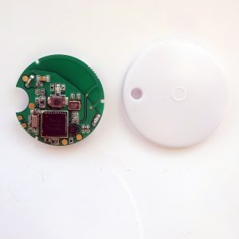

Figure 2.1 nRF51822 Bluetooth Smart Beacon Kit

BLE device is capable to configure it’s transmit power in between -30 and 0 dBm. It’s possible transmit data 30 meters or more, but typical range is around 2 to 5 meters with consider to save more battery life. Bluetooth connections require 2 roles: Central (master), as the receiver. Repeatedly scan preset frequencies for advertising packets and initiate connection. Also manages data exchanges. And peripheral (slave), as the broadcaster. Send advertising packets periodically. Then accept connections. Following central management for data exchanges. (Townsend, Cufí, & Davidson, 2014)

BLE used 2.4 GHz unlicensed frequency (2402 to 2480 MHz) with total of 40 channels (2 MHz for each channel width). And using 3 channels for advertisement or discovery services (channel 37, 38, 39). BLE used same radio frequency as Wi-Fi. But compared to Wi-Fi, BLE use shorter channels and has dedicated advertisement channels. Making BLE receive signal faster and can avoid obstructing Wi-Fi signal. These discovery channels provided very short messages so it can produce higher update rate compared with Wi-Fi advertisement channels that have 20 MHz channel width. (Faragher & Harle, 2015) (Faragher & Harle, 2014)

**2.3 Indoor Positioning System Using Fingerprinting**

Fingerprinting is a method to use RSS signal as a signature from transmitter device to receiver device to estimate position of the device. The main idea is to associate measurable properties with a location within the selected area, means RSS value mapped directly to the location. It divided by 2 phases: Offline phase and Online phase.

Offline phase: Using groups of access point to transmit RSS values and relate them to certain reference point. This relation is stored in a database called radio map. This radio map will contain reference points with stored RSS values from all of the access points that related to the reference point.

Online phase: estimating location of the receiver device. The RSS values received will be compared with the signature in database using localization method to estimate nearest reference point that relate with these received values. A similarity metric is calculated using the RSS values from measurement and RSS values from fingerprinting database, resulting a square Euclidean Distance (Equation 2.4).

(2.4)

Where is the measured RSS value, and is the fingerprint RSS value at indexed location as i.

Localization method is used to execute pattern matching of received RSS values with RSS signatures stored in database. Then find most-closest signature that will be used as representation of receiver’s location. Few popular methods that have been used as localization method are K-Nearest Neighbor (KNN), Support Vector Machine (SVM), Neural Networks, and Bayesian Inference.

K-Nearest Neighbor use received signal strength indicator received then processed the signal to classify nearest values related to certain point that can represent the person’s position. The estimated position is used as centroid of the k-selected locations. These nearest neighbors are ranked using the distance function (Euclidean distance) calculated between centroid and every neighbors. (Yu, et al., 2014). Support Vector Machine is a part of techniques in machine learning to use a supervised learning model to analyze linear or non-linear regression problem. The purpose is to analyze a regression model is capable to represent all nearest data in the regression plane (Xu, Wu, Li, Zhu, & Wang, 2018) (Equation 2.5).

(2.5)

Neural Networks is a method in artificial intelligence that enables a machine to learn ability like human. Works like neuron in human. The usual design is constructed using 3 layers (input, hidden, output) with each nodes in layer are assigned with weight that affect learning rate of the network. Training method using sigmoid function (Equation 2.6) and updating weight using backpropagation algorithm (Tuncer & Tuncer, 2015).

(2.6)

Bayesian Inference is a probabilistic method to estimate position. The estimated position is not constrained to the reference points so it can be anywhere within the deployed area. The probability can be estimated with Maximum Likelihood (Equation 2.7) or expected value over the area (2.8) (Gentile, Alsindi, Raulefs, & Teolis, 2012).

(2.7) (2.8)

**2.4 Deep Learning**

Deep Learning is a method from Machine Learning. Machine learning is used to estimate complicated functions and let machine learn the functions for self-correction using learning algorithm. The learning algorithm used with principle to give experience to the machine by doing a list of tasks and the performance is measured. Most of the learning algorithm have hyperparameters that used to control algorithm’s behavior. One example of learning algorithm is linear regression. As the name implies, it used to solve regression problem. Others are supervised algorithms like Support Vector Machine (SVM), K-Nearest Neighbor (KNN), Decision tree. Unsupervised algorithms examples are principal component analysis, K-means clustering,

Machine learning algorithm must be capable to improve performance at certain task via experience gained in repetition. Tasks in machine learning are what the machine should do. Examples are: Classification, Regression, Transcription, Machine translation, Structured output, Anomaly detection, Synthesis and sampling. Performance measurements are depending the tasks executed. Accuracy or error rate are often used for measurement. Experience of machine learning depends on either supervised or unsupervised learning method that applied to the machine. Unsupervised learning uses a dataset containing many features. The machine extracts these features by itself. Supervised learning uses a dataset contain features but each example associated with a label or target.

Deep learning algorithm in simple way needs a dataset for training and testing, a cost function to measure error rate in learning repetition, an optimization procedure to solve where the gradient of the cost is zero, and a learning algorithm model to solve the problem (Goodfellow, Bengio, Courville, & Bengio, 2016).

**2.5 Convolutional Neural Networks**

A Feedforward deep learning model or also called as multilayer perceptrons (MLP), is a model of neural networks where information flow through inputs, then intermediate computations, finally the outputs. No feedback connections where outputs from the model are used as inputs in next learning iteration. An example of feedforward neural networks is Convolutional Neural Networks (CNN). CNN used to process a grid-like data or matrix that can be applied with mathematical operation called convolution and modified the output using pooling function.

Convolution operation is commutative way for giving weight to the measurement to provide a smoother measurement. CNN requires an input matrix and a kernel to weight the input to produce an output that called as feature map. the input is a multidimensional array of data, while kernel is a multidimensional array of parameters that can be adapted by learning algorithm. The values of inputs and kernels are zero everywhere except points where values stored. Convolution involve 3 important ideas to improve machine learning. Sparse interactions using kernel smaller than the input, parameter sharing that uses same kernel parameter in more than one input functions. And equivariant representations that present the output changes in same way the input changes.

Pooling function replaces output at certain location with a summary statistic of nearby outputs. With purpose to make representation of output approximately invariant to small translation of the input. So the feature placed exactly where it is unaffected by small transformation.

Different Architectures are created by experts to execute CNN. One of the oldest design is LeNet-5 (El-Sawy, Hazem, & Loey, 2016). Using 2 convolutional layers, 2 sub-sampling layers, and 2 fully connected layers. First convolution layer using 5x5 kernel to produce 6 feature maps. Second layer is sub-sampling for automatic feature extraction with 6 feature maps and 2x2 kernel. Third convolution layer using 16 feature maps with 5x5 kernel. Fourth sub-sampling layer using 16 feature maps and 2x2 kernel. Last 2 layers are fully connected layer as MLP.

More recent architectures are CifarNet, AlexNet, and GoogLeNet (Hoo-Chang, et al., 2016). the state-of-the-art is using GoogLeNet. CifarNet using 3 convolution layers, 3 pooling layers, and 1 fully connected layer. First convolution using 5x5 kernel, 1 stride, and 2 paddings. Second pooling layer using 3x3 kernel with 2 strides and zero padding. This will be repeated 3 times until reached fully connected layer. AlexNet architecture use more layers to process input by using 5 convolution layers, 3 pooling layers, and 2 fully connected layers. First convolution layer using 11x11 kernel size, 4 strides, and zero padding. Second pooling layer using 3x3 kernel, 2 strides, and zero padding. Third convolution layer using 5x5 kernel, 1 stride, and 2 paddings. Fourth pooling layer using same configuration with second pooling layer. Fifth through seventh layers are convolution layer using 3x3 kernel, 1 stride, and 1 padding. Eighth pooling layer using same configuration with other pooling layers. Finally, through 2 fully connected layers. GoogLeNet as recent state-of-the-art is using a combined layer that called inception layer (Figure 2.2). GoogLeNet using 2 convolution layers, 2 pooling layers, and 9 inception layers. First convolution layer using 7x7 kernel with 2 strides and 3 paddings. Second pooling layer with 3x3 kernel, 2 strides, and zero padding. Third convolution layer with 3x3 kernel, 1 stride, and 1 padding. Fourth pooling layer with same configuration with second pooling layer, then went through 9 inception layers. Finally, last pooling layer with 7x7 kernel, 1 stride, and zero padding. Figure 2.3 shows architectures of LeNet-5, CifarNet, AlexNet, and GoogLeNet. These architectures, including LeNet-5, mostly are used for image processing CNN with massive size of matrices. In indoor positioning system case, the input matrix is smaller. This means the CNN architecture should be more simplified.

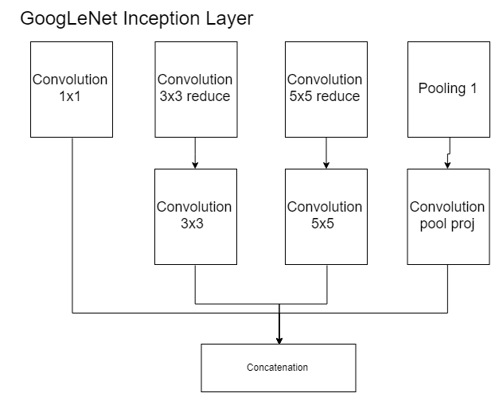

Figure 2.2 GoogLeNet Inception Layer

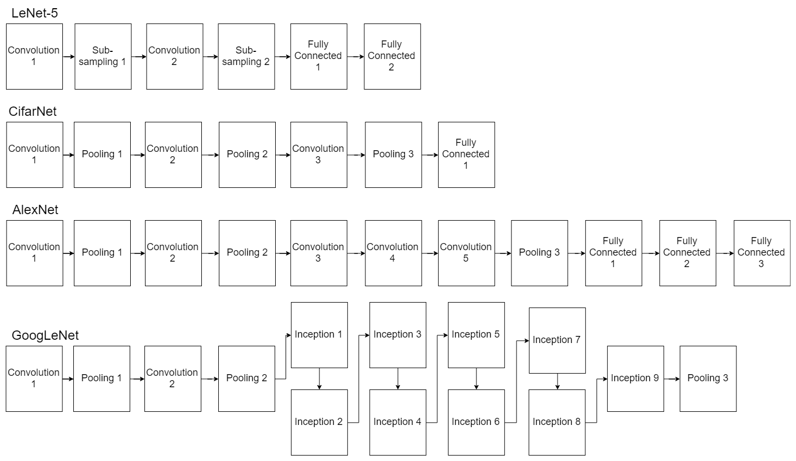

Figure 2.3 Convolutional Neural Networks Architectures

**CHAPTER III**

**METHODOLOGY**

* 1. **Framework of Thought**

Framework of thought to achieve the purpose of this thesis is written in Figure 3.1. First of all, before research started, a problem is needed to be declared. Based from selected state-of-the-art, the fingerprinting method is using distance based, where it has high error rate because of RSS weaknesses like multipath effect and movements of person. From this, I proposed a research using design proposed in this paper. The research process designed is written in Section 3.2 and the proposed design is written in Section 3.3.

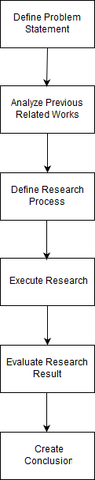

Figure 3.1 Framework of Thought.

To know whether the proposed design is valid or not, the research process must be executed and evaluated. The design after being tested, need to be evaluated to test either the design supported the hypothesis that aimed to solve the problem or not. Evaluation in this case is represented by number of values based from performance metric. Then, a conclusion based from result of the evaluation will be defined as the result of the research.

* 1. **Research Process**

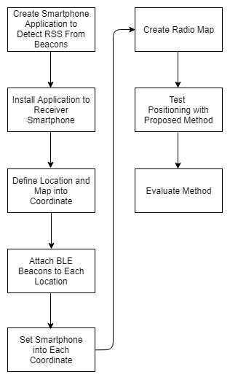

Figure 3.2 Research Process.

Research process to execute the research is shown in Figure 3.2. First, create mobile application (Android application) to receive RSS signal broadcasted by BLE transmitter (nRF51822 Bluetooth Smart Beacon Kit). Then, install the application into receiver smartphone. Now the smartphone is ready as RSS receiver. Next, create a coordinate map (Figure 3.3) based on each location that will be attached with beacon. These locations refer to real location where BLE transmitter attached, represented in coordinate map as reference points. After that, attach the beacons into the locations designated before (represented as access points). BLE transmitter will broadcast the RSS dispersedly. Then using the smartphone installed with application to receive the RSS and map them with position (x and y, inputted by user) of the smartphone in coordinate map. This process will create a database consists of x coordinate values, y coordinate values, and RSS values from each BLE beacons. The process will be repeated until all coordinates have their RSS values. A radio map will be created using this database to train and test the proposed method. The proposed method will be tested by applying the method in the online phase with radio map created to estimate position from person’s smartphone.

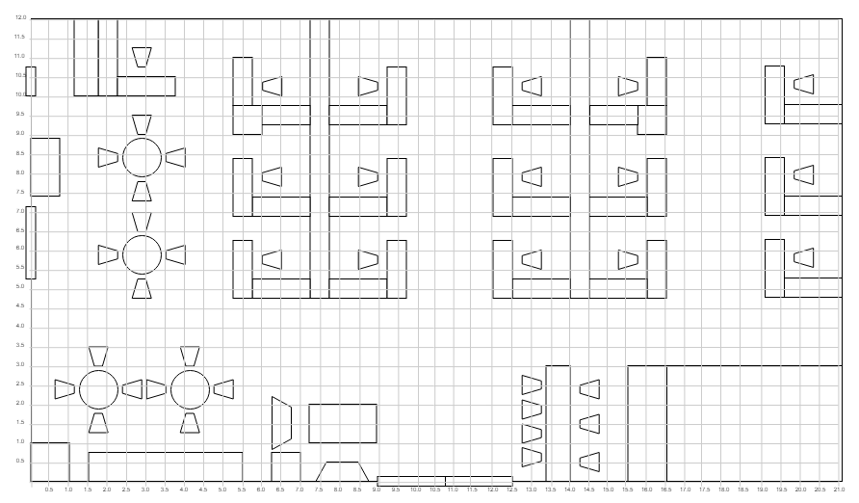

Figure 3.3 Coordinate Map.

* 1. **Proposed Design**

Design proposed in this thesis is indoor positioning using Bluetooth Low Energy (BLE) with regression model for fingerprinting. Where a person carrying a smartphone with activated BLE walking around a room or place filled with BLE beacons. This person’s location will be estimated using deep learning regression method. A database filled with radio map and person RSS record is needed to keep the data.

Tools that needed to receive RSS and to train the radio map are BLE beacons and a smartphone. The BLE is using nRF51822 Bluetooth Smart Beacon Kit as transmitter and using smartphone-embedded BLE as signal receiver. The beacons will be placed at the approximately at a height of 1 meter (estimated height when a person carried the receiver smartphone), and the smartphone will be carried by a person.

In the offline phase, a radio map will be created. A reference point (RP) will be assigned in the map. By standing at the point, the smartphone will receive RSS values from all of the BLE beacons. these RSS values will be stored together with the reference point as a single data in database. This step will be repeated until each reference point in the map has RSS values stored within the database.

In the online phase, position of a person will be estimated using localization algorithm. First, the smartphone receiver will receive RSS values within an interval of 5 seconds. These values will be filtered using Extended Kalmann Filter (EKF) to receive a filtered vector of signal. Then, using K-Nearest Neighbor (KNN) to rank the most nearest reference point around the estimated position. 5 most nearest reference points will be taken as criterions to estimate smartphone position. Each of the reference point’s RSS values will be subtracted with received RSS values in smartphone, resulting a Euclidean distance of RSS value. The distance formula is written in Equation 3.a.

(3.a)

Where is RSS value from smartphone receiver and is the RSS value from i-th reference point in K-Nearest Neighbor ranking. Means there will be 5 Euclidean distances that will used as criterions to estimate position. Then using these distances, together with x position of the reference point that related with the distance, to feed them as inputs of the Deep learning machine. Resulting the estimated x position of the smartphone. These distances will be used again in estimating y position. The deep learning architecture in proposed method’s illustration is represented in Figure 3.4.

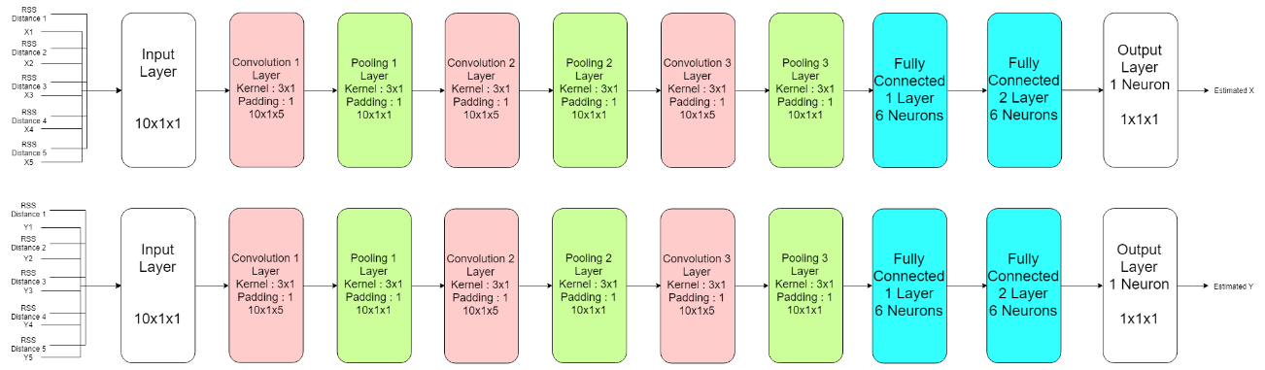

Figure 3.4 Proposed Method’s Illustration

The architecture proposed is inspired by AlexNet deep learning architecture as base principle. Using 10x1 matrix that contains RSS Euclidean distance and position (either x or y) from 5 best ranked reference points as input. The CNN starts with the input go through convolution by 3x1 kernel with 1 padding, so the output of convolution will not change either row or column of kernel matrix. Convolution is done using Rectified Linear Unit (ReLU) as activation function to produce 5 feature maps from a convolution. These results will go through pooling layer to combine them into single 10x1 matrix. This process will be repeated 3 times resulting 10x1 matrix that will go through 2 fully connected layers. The fully connected layers are using linear regression method so the output can be either positive infinite or negative infinite. Finally, the output layer is a neuron that produce 1 value of estimated position (either x or y). The CNN will be repeated for estimating another value of estimated position that has not through CNN process yet.

* 1. **Evaluation**
     1. **Evaluation Method**

The research will be evaluated in quantitative way. Using error rate from Root Mean Square Error (RMSE) produced by the proposed method.

* + 1. **Data Collection**

Data used will be location mapping database collected when training phase. Beacon used will be 15 units. Figure 3.5 show designed location for each BLE beacons. The beacon will be placed with approximately 5 meters in distance of each other beacons. Data collected using smartphone application to read BLE RSS signal. User will input the x and y position, and then click search to retrieve RSS signal with fixed amount of sampling.

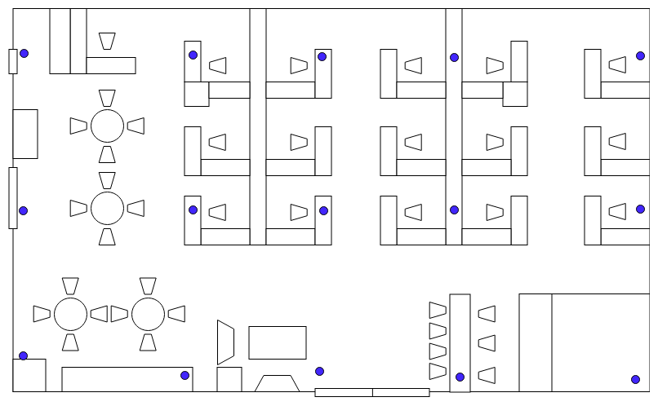

Figure 3.5 Map with 15 Beacons.

Each of these beacons will transmit RSS signal to smartphone receiver. Giving their RSS value and then assign this value with coordinate that represent location of the person carrying smartphone. This will be repeated for each location to create radio map database. Radio map database will be trained based on the methods for online phase to test real position. Data will be sampled for each 0.5m in a room with size of 21m x 12m. Means there will be around 1.000 reference points of position. Each point will be sampled 100 times. The sum of data will be 100.000 data.

* + 1. **Experimental Design**

These data will be stored in radio map database table represented in Table 3.1. For each reference points, every RSS values from each beacons will be averaged into single RSS value. This means that RSS value of each beacons from a single reference point in radio map are from average RSS value of each beacons from 100 samples received.

Table 3.1 Radio Map Database for 15 Beacons Example.

|  |  |  |  |  |  |  |  |  |  |  |  |  |  |  |  |  |  |
| --- | --- | --- | --- | --- | --- | --- | --- | --- | --- | --- | --- | --- | --- | --- | --- | --- | --- |
| **Id** | **X position** | **Y position** | **RSSI 1** | **RSSI 2** | **RSSI 3** | **RSSI 4** | **RSSI 5** | **RSSI 6** | **RSSI 7** | **RSSI 8** | **RSSI 9** | **RSSI 10** | **RSSI 11** | **RSSI 12** | **RSSI 13** | **RSSI 14** | **RSSI 15** |
| **1** | **0.5m** | **0.5m** | **X dBm** | **X dBm** | **X dBm** | **X dBm** | **X dBm** | **X dBm** | **X dBm** | **X dBm** | **X dBm** | **X dBm** | **X dBm** | **X dBm** | **X dBm** | **X dBm** | **X dBm** |
| **2** | **1m** | **0.5m** | **X dBm** | **X dBm** | **X dBm** | **X dBm** | **X dBm** | **X dBm** | **X dBm** | **X dBm** | **X dBm** | **X dBm** | **X dBm** | **X dBm** | **X dBm** | **X dBm** | **X dBm** |
| **3** | **1.5m** | **0.5m** | **X dBm** | **X dBm** | **X dBm** | **X dBm** | **X dBm** | **X dBm** | **X dBm** | **X dBm** | **X dBm** | **X dBm** | **X dBm** | **X dBm** | **X dBm** | **X dBm** | **X dBm** |
| **4** | **1.5m** | **1m** | **X dBm** | **X dBm** | **X dBm** | **X dBm** | **X dBm** | **X dBm** | **X dBm** | **X dBm** | **X dBm** | **X dBm** | **X dBm** | **X dBm** | **X dBm** | **X dBm** | **X dBm** |
| **5** | **1.5m** | **1.5m** | **X dBm** | **X dBm** | **X dBm** | **X dBm** | **X dBm** | **X dBm** | **X dBm** | **X dBm** | **X dBm** | **X dBm** | **X dBm** | **X dBm** | **X dBm** | **X dBm** | **X dBm** |
| **6** | **2m** | **1m** | **X dBm** | **X dBm** | **X dBm** | **X dBm** | **X dBm** | **X dBm** | **X dBm** | **X dBm** | **X dBm** | **X dBm** | **X dBm** | **X dBm** | **X dBm** | **X dBm** | **X dBm** |
| **7** | **3m** | **2m** | **X dBm** | **X dBm** | **X dBm** | **X dBm** | **X dBm** | **X dBm** | **X dBm** | **X dBm** | **X dBm** | **X dBm** | **X dBm** | **X dBm** | **X dBm** | **X dBm** | **X dBm** |
| **…** | **X m** | **X m** | **X dBm** | **X dBm** | **X dBm** | **X dBm** | **X dBm** | **X dBm** | **X dBm** | **X dBm** | **X dBm** | **X dBm** | **X dBm** | **X dBm** | **X dBm** | **X dBm** | **X dBm** |
| **1000** | **21m** | **12m** | **X dBm** | **X dBm** | **X dBm** | **X dBm** | **X dBm** | **X dBm** | **X dBm** | **X dBm** | **X dBm** | **X dBm** | **X dBm** | **X dBm** | **X dBm** | **X dBm** | **X dBm** |

These data will be split into 2 types: training data and testing data. Training data will take 80.000 data (80% of total), and testing data will take 20.000 data (20% of total). Each of them will be randomly sampled based on reference points. The training data will be used for training regression model and evaluated using 8-fold cross validation. The training data will be separated into 8 sub-samples. Each sub-samples will using 10.000 data. 8-fold cross validation will use 1 sub-sample as validation and 7 others for training. Figure 3.6 is example of 10-fold cross validation schema that will be used.

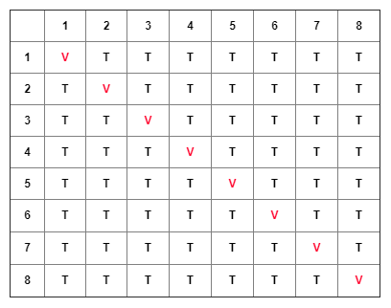

Figure 3.6 8-Fold Cross Validation.

* + 1. **Performance Metric**

The fingerprinting method will be evaluated using Root Mean Square Error (RMSE) (Chai & Draxler, 2014). Where real position will be subtracted by estimated position then square rooted. RMSE used for accuracy measurement, by comparing error rate between 2 models using same dataset. The calculation will be done using Equation 3.6. Where (x, y) is real position and (,) is predicted position.

(3.6)

**BIBLIOGRAPHY**

# 

Abuella, M., & Chowdhury, B. (2015). Solar power probabilistic forecasting by using multiple linear regression analysis. *SoutheastCon 2015* (pp. 1-5). IEEE.

Brena, R. F., García-Vázquez, J. P., Galván-Tejada, C. E., Muñoz-Rodriguez, D., Vargas-Rosales, C., & Fangmeyer, J. (2017). Evolution of indoor positioning technologies: A survey. *Journal of Sensors,2017*.

Čabarkapa, D., Grujić, I., & Pavlović, P. (2015). Comparative analysis of the bluetooth low-energy indoor positioning systems. *2015 12th International Conference on Telecommunication in Modern Satellite, Cable and Broadcasting Services (TELSIKS)*, (pp. 76-79).

Chai, T., & Draxler, R. R. (2014). Root mean square error (RMSE) or mean absolute error (MAE)?–Arguments against avoiding RMSE in the literature. *Geoscientific model development, 7*(3), 1247-1250.

Contreras, D., Castro, M., & de la Torre, D. S. (2017). Performance evaluation of bluetooth low energy in indoor positioning systems. *Transactions on Emerging Telecommunications Technologies, 28*(1), e2864.

Deng, L., & Yu, D. (2014). Deep learning: methods and applications. *Foundations and Trends® in Signal Processing, 7*(3-4), 197-387.

El-Sawy, A., Hazem, E. B., & Loey, M. (2016). CNN for handwritten arabic digits recognition based on LeNet-5. *International Conference on Advanced Intelligent Systems and Informatics* (pp. 566-575). Springer, Cham.

Esfe, M. H., Afrand, M., Yan, W. M., & Akbari, M. (2015). Applicability of artificial neural network and nonlinear regression to predict thermal conductivity modeling of Al2O3–water nanofluids using experimental data. *nternational Communications in Heat and Mass Transfer, 66*, 246-249.

Faragher, R., & Harle, R. (2014). An analysis of the accuracy of bluetooth low energy for indoor positioning applications. *Proceedings of the 27th International Technical Meeting of the Satellite Division of the Institute of Navigation (ION GNSS+’14)*, (pp. 201-210).

Faragher, R., & Harle, R. (2015). Location fingerprinting with bluetooth low energy beacons. *IEEE journal on Selected Areas in Communications, 33*(11), 2418-2428.

Gentile, C., Alsindi, N., Raulefs, R., & Teolis, C. (2012). *Geolocation techniques: principles and applications.* Springer Science & Business Media.

Goodfellow, I., Bengio, Y., Courville, A., & Bengio, Y. (2016). *Deep learning* (Vol. 1). Cambridge: MIT press.

He, S., & Chan, S. H. (2016). Wi-Fi fingerprint-based indoor positioning: Recent advances and comparisons. *IEEE Communications Surveys & Tutorials, 18*(1), 466-490.

Hoo-Chang, S., Roth, H. R., Gao, M., Lu, L., Xu, Z., Nogues, I., . . . Summers, R. M. (2016). Deep convolutional neural networks for computer-aided detection: CNN architectures, dataset characteristics and transfer learning. *IEEE transactions on medical imaging, 35*(5), 1285.

Kuo, Y. S., Pannuto, P., Hsiao, K. J., & Dutta, P. (2014). Luxapose: Indoor positioning with mobile phones and visible light. *Proceedings of the 20th annual international conference on Mobile computing and networking* (pp. 447-458). ACM.

Moutinho, J. N., Araújo, R. E., & Freitas, D. (2016). Indoor localization with audible sound—Towards practical implementation. *Pervasive and Mobile Computing, 29*, 1-16.

Rida, M. E., Liu, F., Jadi, Y., Algawhari, A. A., & Askourih, A. (2015). Indoor location position based on bluetooth signal strength. *Information Science and Control Engineering (ICISCE), 2015 2nd International Conference* (pp. 769-773). IEEE.

Santo, H., Maekawa, T., & Matsushita, Y. (2017). Device-free and privacy preserving indoor positioning using infrared retro-reflection imaging. *Pervasive Computing and Communications (PerCom), 2017 IEEE International Conference*, (pp. 141-152).

Terán, M., Aranda, J., Carrillo, H., Mendez, D., & Parra, C. (2017). IoT-based system for indoor location using bluetooth low energy. In IEEE (Ed.), *Communications and Computing (COLCOM), 2017 IEEE Colombian Conference*, (pp. 1-6).

Thuong, N. T., Phong, H. T., Do, D. T., Van Hieu, P., & Loc, D. T. (2016). Android application for WiFi based indoor position: System design and performance analysis. *Information Networking (ICOIN), 2016 International Conference* (pp. 416-419). IEEE.

Topak, F., Pekeriçli, M. K., & Tanyer, A. M. (2018). Technological Viability Assessment of Bluetooth Low Energy Technology for Indoor Localization. *Journal of Computing in Civil Engineering, 32*(5), 04018034.

Townsend, K., Cufí, C., & Davidson, R. (2014). *Getting started with Bluetooth low energy: tools and techniques for low-power networking.* O'Reilly Media, Inc.

Tuncer, S., & Tuncer, T. (2015). Indoor localization with bluetooth technology using artificial neural networks. *Intelligent Engineering Systems (INES), 2015 IEEE 19th International Conference* (pp. 213-217). IEEE.

Xu, H., Wu, M., Li, P., Zhu, F., & Wang, R. (2018). An RFID Indoor Positioning Algorithm Based on Support Vector Regression. *Sensors, 18*(5), 1504.

Yayan, U., & Yucel, H. (2015). A low cost ultrasonic based positioning system for the indoor navigation of mobile robots. *Journal of Intelligent & Robotic Systems, 78*(3-4), 541-552.

Yu, F., Jiang, M., Liang, J., Qin, X., Hu, M., Peng, T., & Hu, X. (2014). 5 G WiFi Signal-Based Indoor Localization System Using Cluster k-Nearest Neighbor Algorithm. *International journal of distributed sensor networks, 10*(12), 247525.

Zhang, W., Chowdhury, M. S., & Kavehrad, M. (2014). Asynchronous indoor positioning system based on visible light communications. *Optical Engineering, 53*(3), 045105.

Zhuang, Y., Yang, J., Li, Y., Qi, L., & El-Sheimy, N. (2016). Smartphone-based indoor localization with bluetooth low energy beacons. *Sensors, 16*(5), 596.